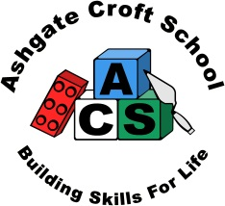
Ashgate Croft School
Person Specification

Job Title | Midday Supervisor | Grade | 4

 | Essential | Desirable | How assessed
Qualifications & Training  - Moving & Handling experience  - Makaton |  |  | A  A
Experience  - Experience of working with children and young people (either paid or unpaid).  - Experience of working with and supervising children and young people with a wide range of special educational needs in a school environment (either paid or unpaid) |  |  | A/ I /R  A/ I /R
Knowledge  - A knowledge and understanding of the welfare and social needs of pupils during the mid-day break  - Awareness of behaviour support |  |  | I / R  I / R
Skills and Abilities  - Effective communication skills.  - Good basic literacy skills.  - Ability to be flexible and work in different areas of the school  - Able to move and handle pupils, attend to their personal care needs and to use physical intervention within the school’s policies | . |  | I / R  A  I / R  I
Factors not already covered
Must be able to perform all duties and tasks with reasonable adjustment, where appropriate, in accordance with the provisions of Disability Discrimination Act 1995.

Ashgate Croft is committed to safeguarding and promoting the welfare of children and young people and expects all staff and volunteers to share this commitment This post will be subject to satisfactory references and enhanced DBS clearance

A = Application Form
I = Interview
R = Reference

